Technology Stack (Architecture & Stack)
Date | 16 February 2026
Team ID | LTVIP2026TMIDS89357
Project Name | Explore with Ai: custom itineraries for your next journey
Maximum Marks | 4 Marks

Technical Architecture:
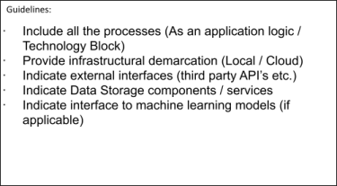
The Deliverable shall include the architectural diagram as below and the information as per the table1 & table
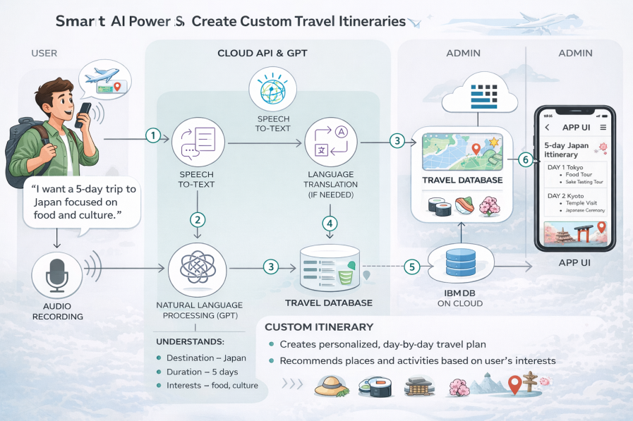

Table-1 : Components & Technologies:
S.No | Component |  |  | Description | Technology
1 | User Interface |  |  | Interface where users interact with the system through Web App, Mobile App, or Voice/Chat interface to request travel itineraries | HTML, CSS, JavaScript, React JS / Angular JS, Mobile App (Flutter / Android / iOS)
2 | Application Logic-1 |  |  | Core backend logic to handle user requests, itinerary generation workflow, API integration, and response management | Python (Flask / Django) or Java (Spring Boot)
3 | Application Logic-2 |  |  | Converts user voice input into text for processing travel requests | IBM Watson Speech-to-Text (STT) Service
4 | Application Logic-3 |  |  | Conversational AI logic to understand user intent, preferences, and generate personalized travel responses | IBM Watson Assistant
5 | Database |  |  | Stores user profiles, preferences, itinerary history, destinations, and travel metadata | MySQL / PostgreSQL / MongoDB (NoSQL)
6 | Cloud Database |  |  | Cloud-based managed database for scalable storage and fast access | IBM DB2 on Cloud / IBM Cloudant
7 | File Storage |  |  | Stores audio recordings, travel documents, images, and  generated itinerary files | IBM Cloud Object Storage / IBM Block Storage
8 | External API-1 |  |  | Provides travel-related information such as weather forecasts, location details, and travel conditions | IBM Weather API / OpenWeather API / Google Maps API
9 | External API-2 |  |  | Provides user authentication, identity verification, or  travel services integration | Aadhar API / Google Places API / Flight & Hotel
 |  |  |  |  | APIs (Amadeus, Skyscanner)
10 | Machine Learning Model |  |  | Processes natural language input, extracts entities (destination, duration, interests), and generates personalized itinerary recommendations | IBM Watson Natural Language Understanding / Watson Knowledge Studio / Custom ML Model (Python, TensorFlow, or GPT-based model)
11 | Infrastructure |  |  | Hosts and deploys the application backend, AI services, database, and storage components | IBM Cloud, Kubernetes, Docker Containers, Cloud Foundry

Table-2: Application Characteristics:

S.No | Characteristics | Description | Technology
1 | Open-Source Frameworks | Open-source frameworks are used to build the frontend, backend, and APIs for the travel itinerary system. These frameworks provide flexibility, faster | Frontend: React JS / Angular JSBackend: Python Flask / Django or Java Spring BootAPI Framework: REST APIsContainerization: Docker
2 | Security Implementations | The system ensures secure communication, authentication, and data protection. User data and travel information are protected using encryption, access control, and secure communication protocols. | HTTPS (SSL/TLS Encryption)SHA-256 Password HashingIBM Cloud IAM (Identity and Access Management)OAuth 2.0 AuthenticationFirewall and Network Security (IBM Cloud Security Groups)OWASP Secure Coding Practices
3 | Scalable Architecture | The application uses a scalable cloud-based microservices architecture. Each service (Speech-to-Text, Assistant, Backend, Database) can scale independently based on user demand. | Microservices ArchitectureIBM Cloud Kubernetes ServiceDocker ContainersIBM Cloud Auto-ScalingREST API Architecture
4 | Availability | High availability is ensured through distributed cloud infrastructure, load balancing, and managed cloud services. The system remains operational even if one component fails. | IBM Cloud Load BalancerDistributed Cloud ServersIBM DB2 High AvailabilityKubernetes Cluster DeploymentMulti-Zone Deployment
5 | Performance | The system is optimized for fast response and handling multiple users simultaneously. Caching, optimized database queries, and scalable cloud infrastructure improve performance. | Redis Cache (optional)IBM Cloud CDNOptimized DB2 QueriesREST API OptimizationCloud Auto-ScalingAsynchronous Processing

